**SPRINT 3 PLANNING**



**Author: Imagineers Team**

**Date: 18/03/2017**

**Revision history**

|  |  |  |  |
| --- | --- | --- | --- |
| **Version** | **Date** | **Author** | **Notes** |
| 1.0 | 18/03/2017 | Thạch Nguyễn | Create Document |
|  |  |  |  |

Contents

I. INTRODUCTION 4

1. Purpose 4

2. Audience 4

II. SPRINT 3 GOALS 4

III. SPRINT 3 BACKLOG 4

IV. SPRINT 3 TASK 5

V. SPRINT 3 DEFINTION OF DONE 9

# INTRODUCTION

## Purpose

This document describes how sprint 3 is planning. The plan describes in simple, straight forward term the processes required to ensure that the sprint 3 stories are estimated and ensures the goals of sprint 3.

## Audience

This document is created for Scrum team .

# SPRINT 3 GOALS

* This is the first sprint execution so the priority of the product as customer wishes is to have the profile of the member. Because every swap activities will base on the profile
* The next goal is finishing the sprint 3 selected stories with full artifacts that is defined in the “definition of done”
* Finishing the sprint 3 on time. With all the stories that was chosen to put in sprint 3
  + Member create profile (cont)
  + View Introduction line ( head banner )
  + Edit Introduction line ( head banner )
  + Member view my page
  + Member edit my page
  + Member view about me
  + Member edit about me
  + Member view review page
  + Search skills

# SPRINT 3 BACKLOG

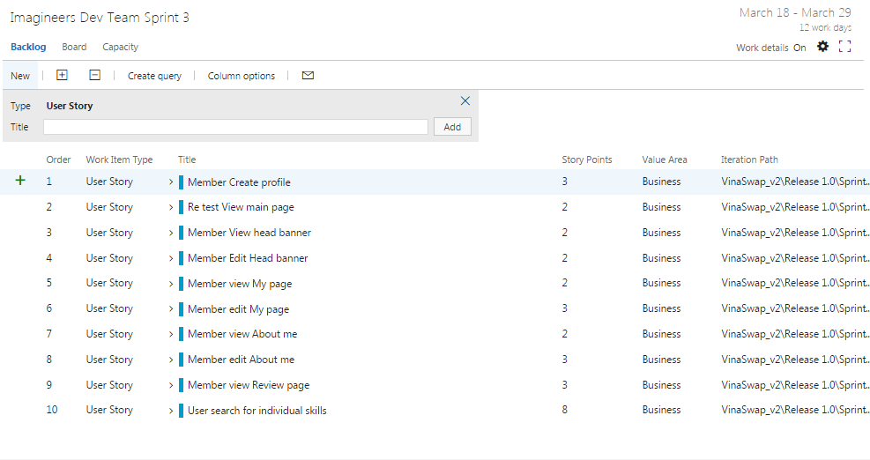

# SPRINT 3 TASK

|  |  |  |  |  |  |
| --- | --- | --- | --- | --- | --- |
| User story | Task | Assigned | Estimation (hrs) | Actual  (hrs) | Status |
| Member Create profile | Write Unit test – create profile server side | Tai Nguyen | 12 |  |  |
|  | Run unit test – create profile server side | Tai Nguyen |  |  |  |
|  | Write Unit test – create profile client side | Tai Nguyen | 10 |  |  |
|  | Run Unit test – create profile client side | Tai Nguyen | 4 |  |  |
|  | Code HTML/CSS – create profile | Quang Nguyen | 8 |  |  |
|  | Code client side– create profile | Quang Nguyen | 16 |  |  |
|  | Review code | Chanh Tran | 2 |  |  |
|  | Run functional test case- View main page | Viet Dang | 8 |  |  |
|  | Write acceptance test – create profile | Phuong Nguyen | 1 |  |  |
|  | Write test report – create profile | Viet Dang | 5 |  |  |
|  | Build Deploy | Thach Nguyen | 2 |  |  |
|  |  |  |  |  |  |
| Retest view main page | Write Unit test – view main page server side | Tai Nguyen | 8 |  |  |
|  | Run Unit test – view main page server side | Tai Nguyen | 4 |  |  |
|  | Write unit test – view main page client side | Tai Nguyen | 8 |  |  |
|  | Run unit test – view main page client side | Tai Nguyen | 4 |  |  |
|  | Write acceptance test | Phuong Nguyen | 1 |  |  |
|  | Run functional testcase – view main page | Viet Dang | 2 |  |  |
|  |  |  |  |  |  |
| Member view head banner | Code client side – view head banner | Quang Nguyen | 16 |  |  |
|  | Code HTML/CSS | Viet Dang | 16 |  |  |
|  | Write unit test – server side | Tai Nguyen | 10 |  |  |
|  | Run unit test – server side | Tai Nguyen | 1 |  |  |
|  | Write unit test – client side | Tai Nguyen | 10 |  |  |
|  | Run unit test – client side | Tai Nguyen | 1 |  |  |
|  | Review code | Chanh Tran | 2 |  |  |
|  | Write test report – view head banner | Viet Dang | 5 |  |  |
|  | Build – view head banner | Thach Nguyen | 2 |  |  |
|  |  |  |  |  |  |
| Member edit head banner | Code client side – edit head banner | Quang Nguyen | 20 |  |  |
|  | Code HTML/CSS | Viet Dang | 16 |  |  |
|  | Code server side | Chanh Tran | 20 |  |  |
|  | Review code | Chanh Tran | 2 |  |  |
|  | Write test report – edit head banner | Viet Dang | 5 |  |  |
|  | Run functional test – edit head banner | Viet Dang | 8 |  |  |
|  | Write acceptance test | Phuong Nguyen | 5 |  |  |
|  | Write Unit test – edit head banner client side | Tai Nguyen | 8 |  |  |
|  | Run unit test – edit head banner client side | Tai Nguyen |  |  |  |
|  | Write Unit test – edit head banner server side | Tai Nguyen |  |  |  |
|  | Build deploy – edit head banner | Thach Nguyen | 2 |  |  |
|  |  |  |  |  |  |
| Member view my page | Code HTML/CSS | Quang Nguyen | 16 |  |  |
|  | Code client side – view my page | Quang Nguyen | 16 |  |  |
|  | Code server side – view my page | Chanh Tran |  |  |  |
|  | Write unit test – view my page client side | Tai Nguyen | 10 |  |  |
|  | Run unit test – view my page client side | Tai Nguyen | 4 |  |  |
|  | Write unit test – view my page server side | Tai Nguyen | 10 |  |  |
|  | Run unit test – view my page server side | Tai Nguyen |  |  |  |
|  | Write acceptance test | Phuong Nguyen | 1 |  |  |
|  | Run functional test – view my page | Viet Dang | 2 |  |  |
|  | Build – view my page | Thach Nguyen | 2 |  |  |
|  | Write test report | Viet Dang |  |  |  |
|  |  |  |  |  |  |
| Member edit my page | Code HTML/CSS | Quang Nguyen | 16 |  |  |
|  | Code client side – edit my page | Quang Nguyen | 16 |  |  |
|  | Code server side – edit my page | Chanh Tran | 16 |  |  |
|  | Write unit test – edit my page client side | Tai Nguyen | 6 |  |  |
|  | Run unit test – edit my page client side | Tai Nguyen | 6 |  |  |
|  | Write unit test – edit my page server side | Tai Nguyen | 6 |  |  |
|  | Run unit test – edit my page server side | Tai Nguyen | 6 |  |  |
|  | Write acceptance test | Phuong Nguyen | 2 |  |  |
|  | Run functional test | Viet Dang | 8 |  |  |
|  | Build – edit my page | Thach Nguyen | 2 |  |  |
|  |  |  |  |  |  |
| Member view about me | Code HTML/CSS | Quang Nguyen | 16 |  |  |
|  | Code client side – view about me | Quang Nguyen | 16 |  |  |
|  | Code server side – view about me | Chanh Tran | 16 |  |  |
|  | Write unit test – view about me client side | Tai Nguyen | 12 |  |  |
|  | Run unit test – view about me client side | Tai Nguyen | 3 |  |  |
|  | Write unit test – view about me server side | Tai Nguyen | 12 |  |  |
|  | Run unit test – view about me server side | Tai Nguyen | 3 |  |  |
|  | Run functional test | Viet Dang | 2 |  |  |
|  | Write acceptance test | Phuong Nguyen | 1 |  |  |
|  | Build – view about me | Thach Nguyen | 2 |  |  |
|  |  |  |  |  |  |
| Member edit about me | Code HTML/CSS | Quang Nguyen | 16 |  |  |
|  | Code client side – edit about me | Quang Nguyen | 16 |  |  |
|  | Code server side – edit about me | Chanh Tran | 16 |  |  |
|  | Write unit test – edit about me client side | Tai Nguyen | 12 |  |  |
|  | Run unit test – edit about me client side | Tai Nguyen |  |  |  |
|  | Write unit test – edit about me server side | Tai Nguyen | 12 |  |  |
|  | Run unit test – edit about me server side | Tai Nguyen |  |  |  |
|  | Run functional test | Viet Dang | 8 |  |  |
|  | Write acceptance test | Phuong Nguyen | 1 |  |  |
|  | Build – view about me | Thach Nguyen | 2 |  |  |
|  |  |  |  |  |  |
| Member view review page | Code HTML/CSS | Quang Nguyen | 16 |  |  |
|  | Code client side – view review page | Quang Nguyen |  |  |  |
|  | Code server side – view review page | Chanh Tran |  |  |  |
|  | Write unit test – view review page client side | Tai Nguyen | 12 |  |  |
|  | Run unit test – view review page client side | Tai Nguyen |  |  |  |
|  | Write unit test – view review page server side | Tai Nguyen | 12 |  |  |
|  | Run unit test – view review page server side | Tai Nguyen |  |  |  |
|  | Run functional test | Viet Dang | 2 |  |  |
|  | Write acceptance test | Phuong Nguyen | 1 |  |  |
|  | Build – view review page | Thach Nguyen | 2 |  |  |
|  |  |  |  |  |  |
| User search for individual skills | Design UI | Phuong Nguyen | 8 |  |  |
|  | Design database | Thach Nguyen | 12 |  |  |
|  | Code HTML/CSS | Quang Nguyen |  |  |  |
|  | Code client side – search skills | Quang Nguyen | 24 |  |  |
|  | Code server side – search skills | Chanh Tran |  |  |  |
|  | Write unit test – search skills client side | Tai Nguyen |  |  |  |
|  | Run unit test – search skills client side | Tai Nguyen |  |  |  |
|  | Write unit test – search skills server side | Tai Nguyen | 12 |  |  |
|  | Run unit test – search skills server side | Tai Nguyen |  |  |  |
|  | Run functional test | Viet Dang |  |  |  |
|  | Write acceptance test | Phuong Nguyen |  |  |  |
|  | Build – search skills | Thach Nguyen |  |  |  |

# SPRINT 3 DEFINTION OF DONE

|  |  |  |
| --- | --- | --- |
| Category | Detail | Artifacts |
| User Story Clarity | User stories selected for the sprint are complete with respect to product theme, understood by the team, and have been validated by the detailed acceptance criteria. | Product backlog/ User story |
| Tasks Identified | Tasks for selected user stories have been identified and estimated by the team. - |  |
| Product owner approval | Each finished user story has been passed through UAT (User Acceptance Testing) and signed off as meeting requirements | References : Acceptance test |
| Updating Product Backlog | All features not done during the sprint are added back to the product backlog. All incidents/defects not handled during the sprint are added to the product backlog. | Imagineers-Productbacklog |
| Environment ready | Development environment is ready with all third-party tools configured.  Staging environment is ready.  Continuous integration framework is in place  Test data for the selected features has been created | Task management : Team service  Coding: Visual code  Document: Microsoft Office |
| Design complete | Design analysis is complete as per the user story or theme.  Prototype have been created and approved by the respective stakeholders.  Use cases are developed | Imagineers-Usecase  Imagineers-Prototype |
| Unit test cases written | Unit test cases have been written for the features to be developed |  |
| Documentation Ready | Documentation to support the sprint demo is ready |  |
| Code Complete | Source code changes are done for all the features in the “to do” list.” Source code has been commented appropriately. |  |
| Unit testing is done | Unit test cases have been executed and are working successfully |  |
| Code Refactoring | Source code has been refactored to make it comprehensive, maintainable and, amenable to change. |  |
| Code checkin | Source code is checked in the code library with appropriate comments added. |  |
| Code merging and tagging | Finalized source code has been merged with the main branch and tagged appropriately (merging and tagging guidelines are to be used) |  |
| Project metrics are ready | Burndown chart has been updated regularly and is up to date. |  |
| Functional testing done | Test team has reviewed and conducted necessary manual test cases to ensure that tests are passing. All incidents/defects are reported.  100% executed test cases and 80% test cases pass.  There are no major defect occurred  Accept 20% minor defects in layout or the defect doesn’t affect system | Imagineers-TestCase  Imagineers-TestReport |
| Acceptance testing done | Each finished user story has been passed through UAT (User Acceptance Testing) and signed off as meeting requirements (see also Product Owner Approval). | Imagineers-AcceptanceTest |
| Closure | All finished user stories/tasks are marked complete/resolved. Remaining hours for task set to zero before closing the task. |  |